MEMBERSHIP FORM
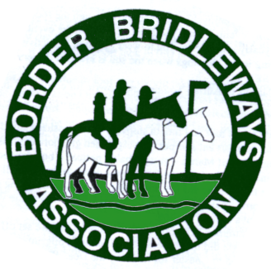

Please send this form via email to Katie at borderbridleway@gmail.com

Name(s) ……………………………………………….........……………………………………

…………………………………….........…………………………………………………

Address ………………………...........…………………………………………………………..

…………………………………...........…………………………………………………..

…………………………………...........…………………………………………………..

Mobile …….……….……..............................

Email address …………………………………………………………………............…………

Emergency contact details ………………………………………………………………………

Type of membership (delete as appropriate & list all individuals above):
Single Membership (£10.00)
Joint (Two members at the same address, £15.00)
Family (any no. in family, £20.00)

BACS £…………… in respect of annual membership.

I accept the BBA privacy policy (available on the website) YES/NO

Signed …………………………………………………………………Date …………………

Payment via bacs to The Cheshire/Staffordshire Border Bridleways Association using your name and member as reference.
Account number 01471260 Sort Code 40-18-09

This form can be used for renewals or new membership/subscription. BBA membership runs from January to December each year, If joining after September membership will roll over to December the following year. Membership must be up to date to attend any BBA events. More details can be found on the website www.borderbridleways.org.uk
Updated January 2026

